

ÇANKAYA UNIVERSITY

FACULTY OF ENGINEERING COMPUTER ENGINEERING DEPARTMENT

CENG408

USER MANUAL REPORT

ATAKAN GÖKNAR 201711029

SERTAN UMUT GÜREL 201711031

TONGUÇ BERAT ÖZEL 201711050

ATAKAN TANER GÜL 201811033

**HOME PAGE**

taşıt, araç, metin, kara taşıtı, araba içeren bir resim

Açıklama otomatik olarak oluşturuldu

It is the first login page that appears when the user logs in to the page. At the bottom of the page are the names and information of the developers of the project.

**FIND NEAREST GAS PAGE**

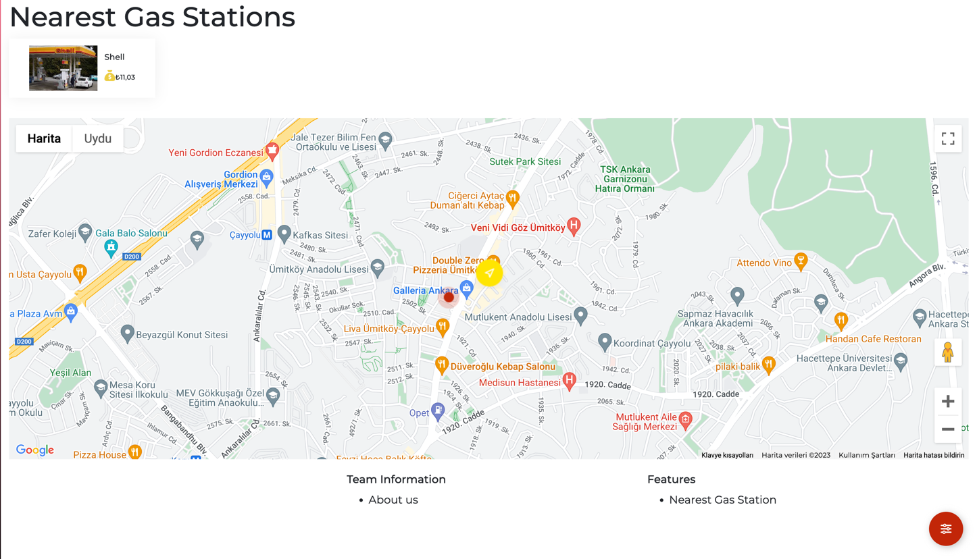

It is the page that appears when the user clicks on the nearest gas page from the homepage. The user can see the gas stations and their prices from the boxes on the map, according to their location. The current location of the user is indicated on the map as a yellow circle. Gas stations around it appear as a red circle.

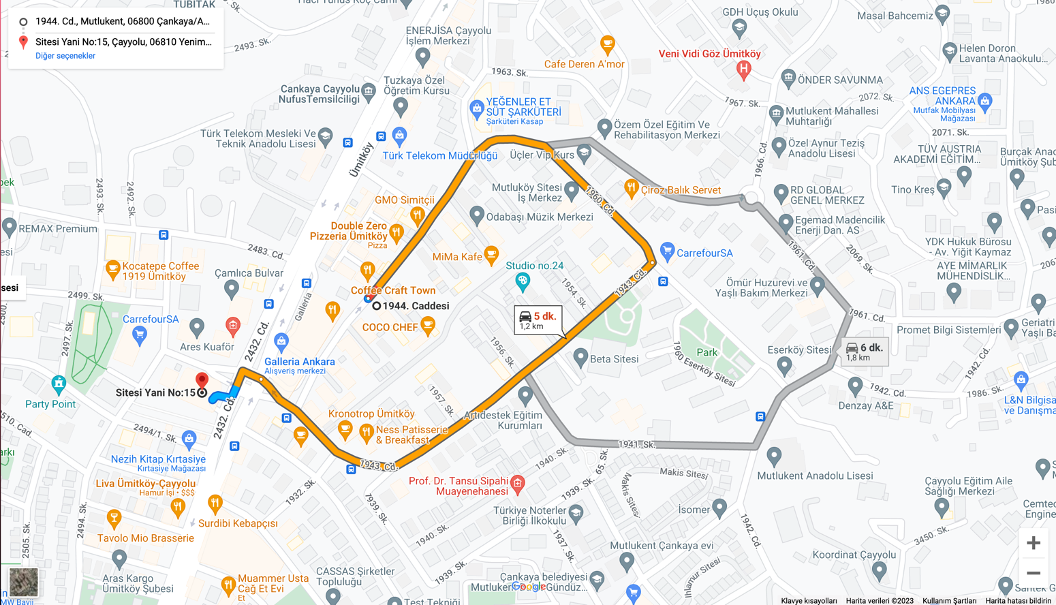

When the user clicks on the box of the gas station he/she wants to go to,he/she shows the route on the map as in the picture above.

**FAQ PAGE**

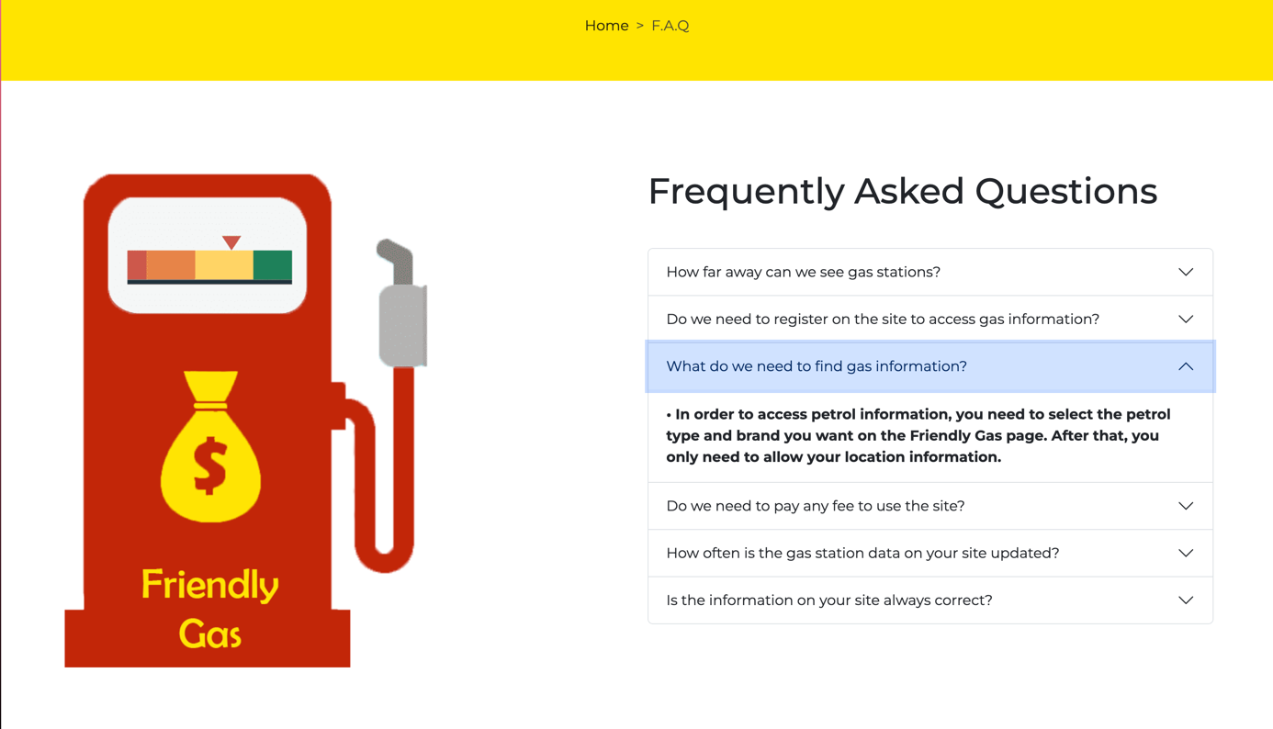

It is the page where the questions that users generally ask are displayed. Users can click on the questions and see the answers to the questions.

**ADMIN PAGE**

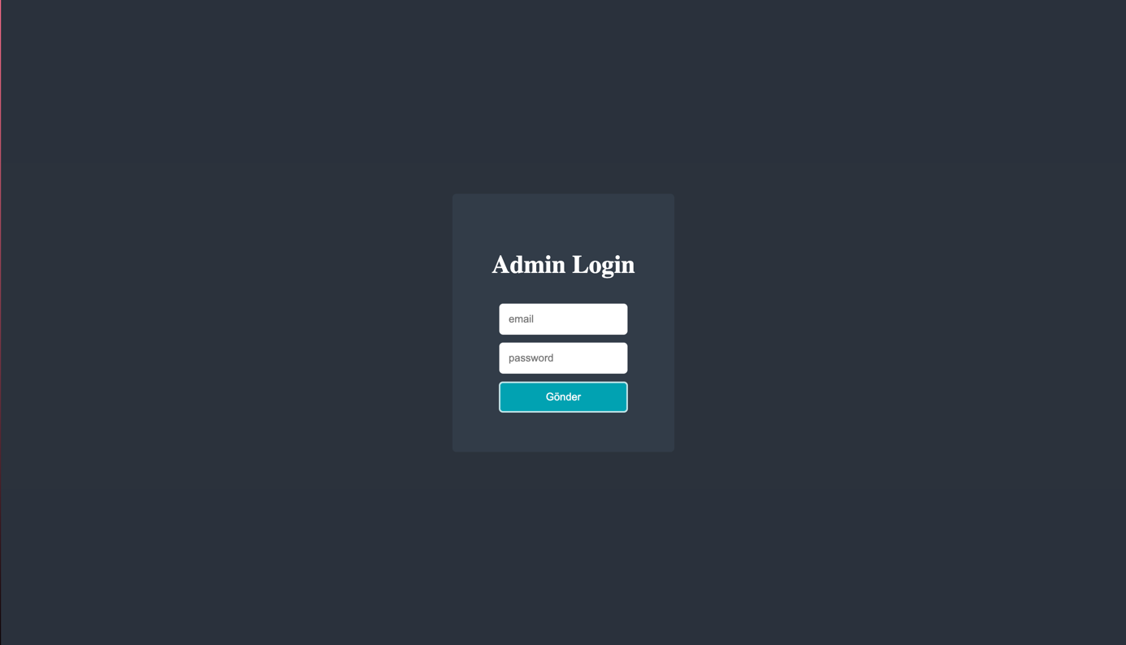

It is the page where the admin logs in to update the questions and answers on the FAQ page.

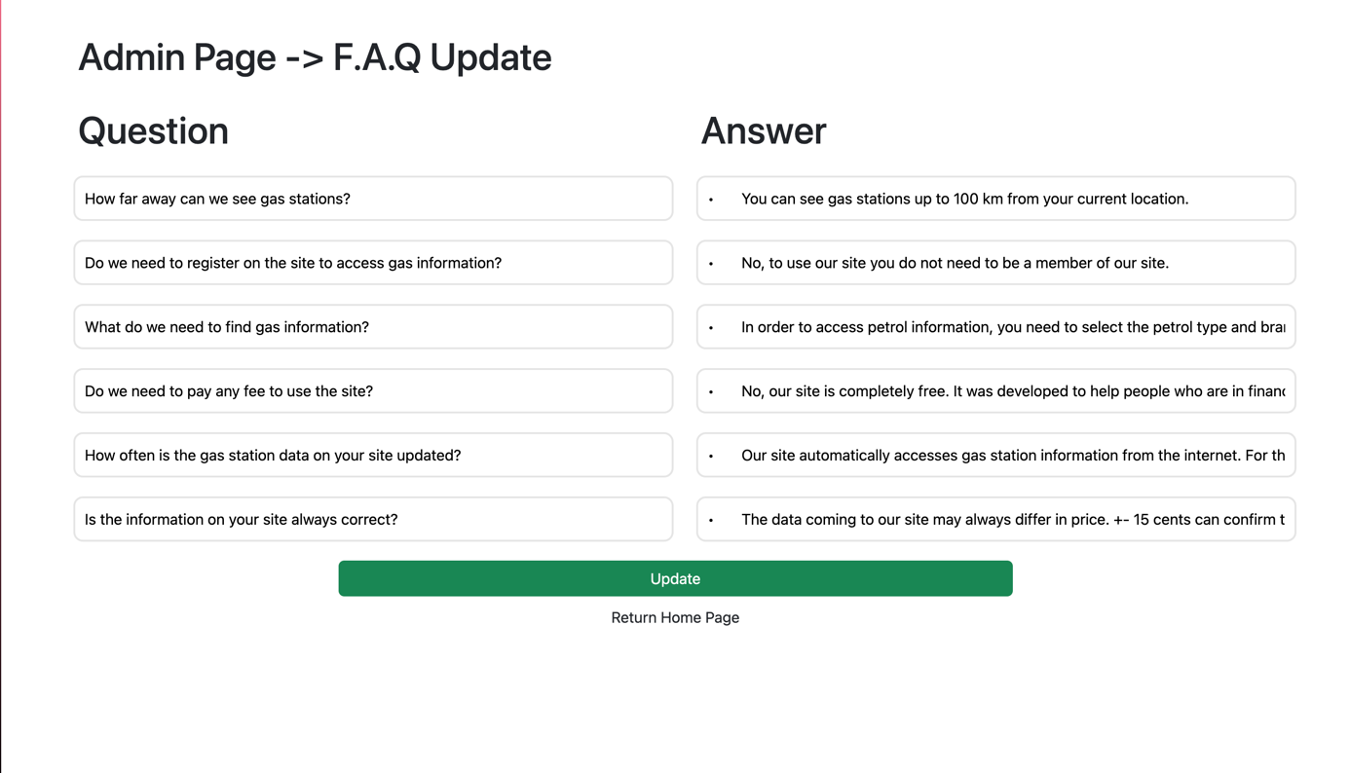

It is the page where the Admin updates the questions and answers in the FAQ after logging in from the login page.